Your report belongs to you. Many participants enjoy sharing their report with friends and family and peers (co-workers, fellow students, romantic partners, etc.) but the decision to do so is up to you. We do not keep any identifying information and we do not store cookies on your computer/device. This means that **your scores will be lost when you close your browser window.** You are welcome to complete the assessment more than once but you MUST tell us that you have taken the assessment previously — answer "yes" to the first question on the first page. This is important for the integrity of our research.

**If you want to keep your report, I recommend printing it [How?] or, better yet, saving it as a PDF [How?] for future reference. If you'd like to have a copy of the image showing your SPI 27 Factor Trait Scores, you can download it from most browsers by clicking the download arrow at the bottom. If you are unable to download the image (this feature is disabled by some phone browsers), I recommend taking a screenshot.**

### Your Personality Report

# (scroll down to see the full report.)

Here's the full report on your personality profile, including your scores on

1. the 27 narrow traits of the SPI-27,
2. your scores on the Big Five traits (the SPI-5), and
3. your cognition score.

[**Click here for advice about saving your report.**](https://sapa-project.org/survey/report.php) **[Not helpful.]**

**ONE: SPI 27 Factor Trait Scores**

This figure provides a visual summary of your scores on the factors of the SPI-27. The black line down the middle indicates the average score for each trait. The colored bars show how much you scored above the average (the colored bar extends out to the right from the mid-line) or below the average (left of the mid-line). If your score matches the average, you won't see any color.

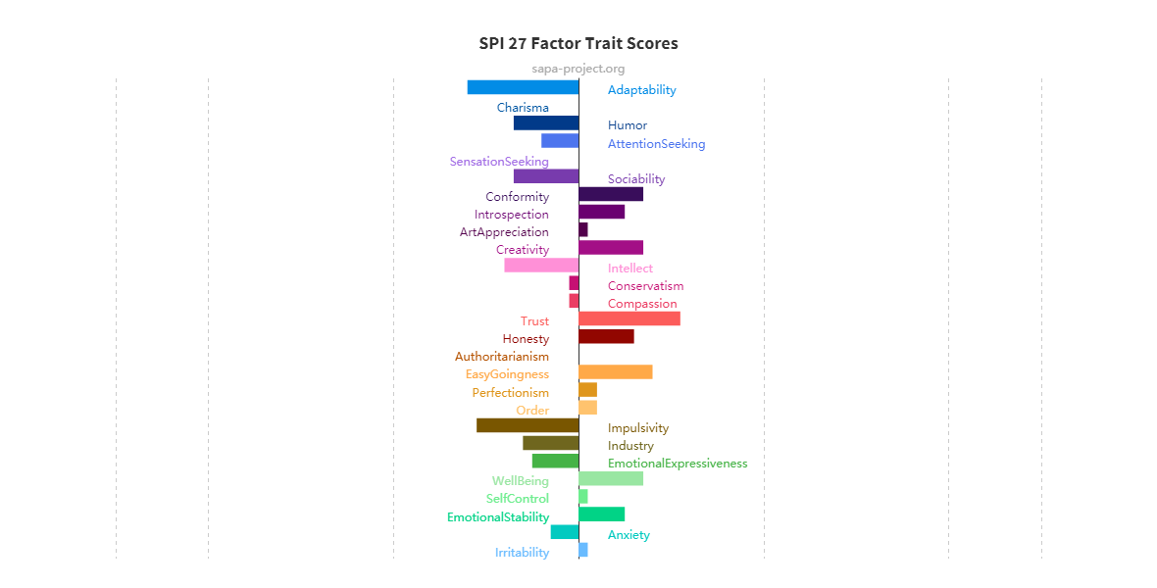

**[A little click thingy here got me the above as a .png image in my download folder.   
However, only the online version you loose interactively shows your numeric scores.]**

**download the image**

The next section gives more detailed descriptions of each trait and some thoughts about the meaning of your scores. By default, we only show the feedback for your 4 most extreme scores. **To see your scores on all of the factors, click the link at the bottom of this box.**

### ****Adaptability****

An adaptable individual is someone who can more readily adjust to changes in their environment. They are more likely to crave novelty and variety in their life, and to find themselves bored with routine. Adaptability also relates to one's ability to perform on the fly, or conversely to one's preference for comprehensive planning. Individuals low in Adaptability may find themselves more flustered by change, as they prefer plans and the stability of repetition. Not knowing what will come next is more a source of concern or frustration than of excitement.

**Your score of 38 on Adaptability places you higher than 12% of previous participants in this survey.**

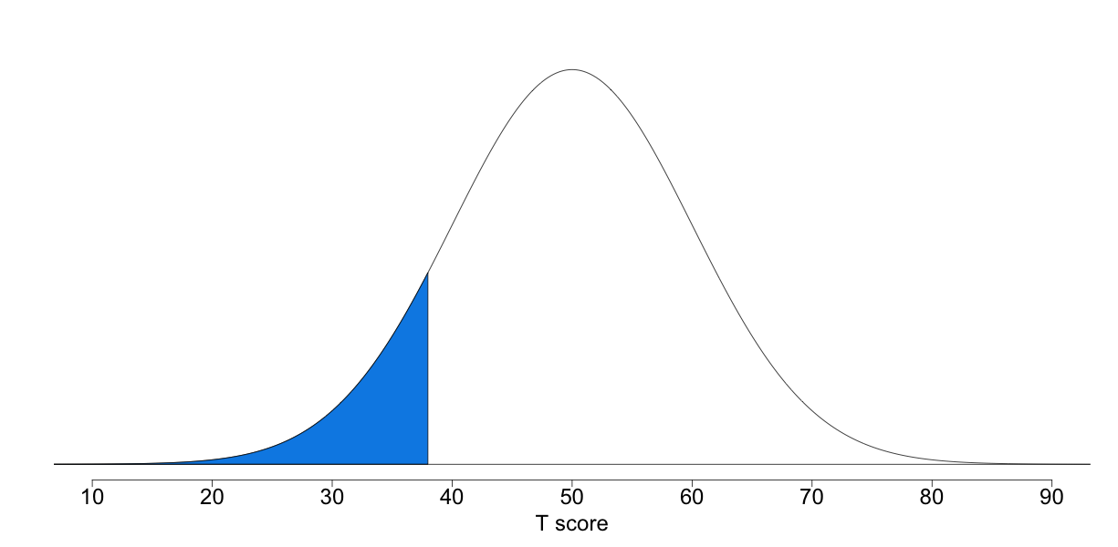

[click for more info about reading this image](https://sapa-project.org/survey/report.php)

Your score on the Adaptability scale indicates that you are low in Adaptability. Most likely, you take longer to accept change and to adjust to it. You probably take care to stick to the routines that work well for you in your daily life. You may not particularly like surprises or sudden turns in fate. In your life, you may work steadily to establish stability and security.

"The secret of your future is hidden in your daily routine."  
— Mike Murdock

### ****Impulsivity****

The trait of Impulsivity reflects the tendency to act on a whim, displaying behavior characterized by little or no forethought, reflection, or consideration of the consequences. Attitudes about Impulsivity in popular culture are often varied and this leads to a stew of mixed messages. While the prevailing sentiment in Western pop culture encourages spontaneity ("carpe diem!"), the consequences of rash behavior are often really unpleasant. More impulsive individuals are more likely to jump into things without consideration of the consequences and make decisions very quickly. For some, this tendency is part of a broader worldview that life is better lived in the moment, through bold actions and no regrets.  
In light of evidence that "gut" intuitions are often as good or better than strategic approaches to decision-making in situations with many uncontrollable factors, it can be hard to argue against the Impulsive approach to life. But only to a point. Less impulsive individuals tend to be more successful at tasks that require planning, preparation and persistence — and these tasks include many of those needed for a healthy and productive life. Low impulsivity is also beneficial for social relationships, as it is associated with greater reliability, consistency, and consideration of the consequences of one's behavior on friends and family.

**Your score of 39 on Impulsivity places you higher than 14% of previous participants in this survey.**

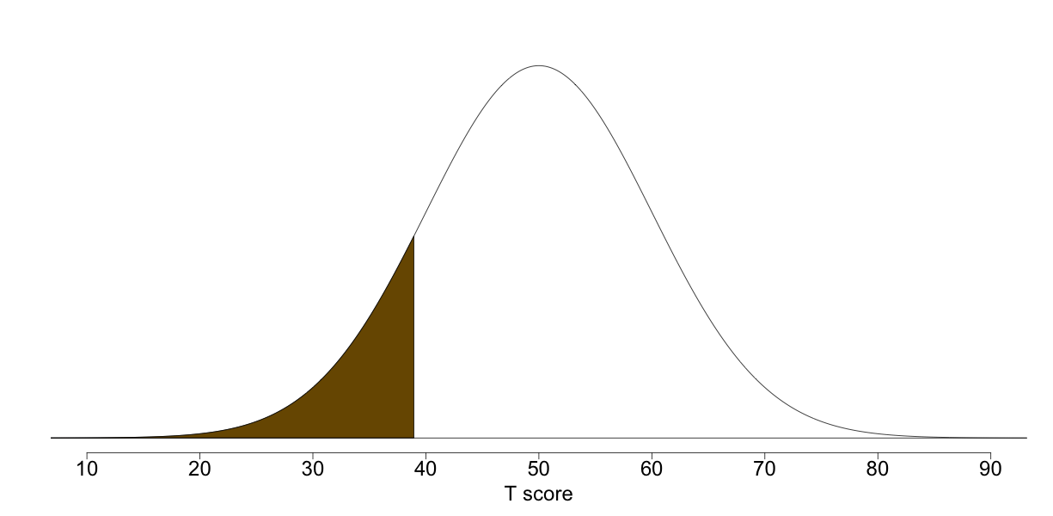

[click for more info about reading this image](https://sapa-project.org/survey/report.php)

Your score on the Impulsivity scale indicates that you are less Impulsive than most people. It is likely that you rarely make rash decisions or act without thinking. You probably think strategically and prefer comprehensive planning. In social interactions, you are probably among the most prepared and the voice of reason. More impulsive friends may sometimes accuse you of being a bit of a killjoy, but that's because you are typically thinking about what is really in everyone's best interests long-term. You know better than anyone that it's important not to sacrifice future safety and happiness for a short moment of fun.

"Every impulse of feeling should be guided by reason."  
— Jane Austen, 'Pride and Prejudice'

### ****Trust****

Trust measures an individual's comfort at taking others at their word, and their willingness to believe things as they are presented. It also relates to ones' beliefs about the motivations of others and the extent to which others will treat them with fairness and objectivity. Individuals high in Trust are generally more likely to have an optimistic view of human nature and less likely to doubt the intentions of others. By contrast, those who are low in Trust tend to be hesitant about exposing their vulnerabilities to others. They're also often reluctant to take others at their word — they reach their own conclusions only after careful consideration of the facts.

**Your score of 61 on Trust places you higher than 86% of previous participants in this survey.**

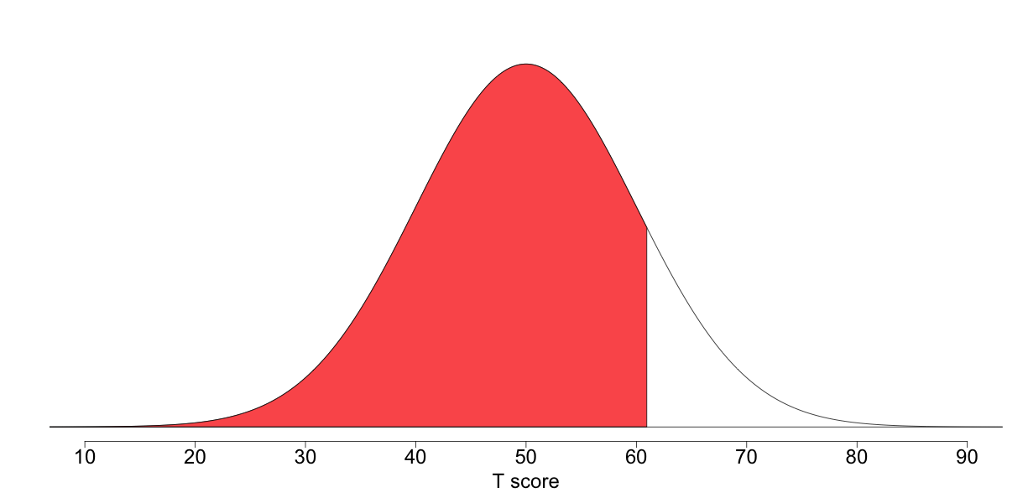

[click for more info about reading this image](https://sapa-project.org/survey/report.php)

Your score on the Trust scale indicates that you are very high in Trust. You probably believe in the fundamental honesty and goodness of human beings and are likely to take people at their word. You may therefore be more likely to accept people into your life. Though some might mistake your faith in humanity for gullibility, others are inspired by your trusting nature and wish to embody it.

"Alone we can do so little, together we can do so much."  
— Helen Keller

### ****Intellect****

The Intellect scale measures how quickly an individual grasps new concepts, and how much information they can mentally handle at once. A person's Intellect score is not necessarily a complete indicator of how "smart" they are, let alone how much they know, but rather a more specific measure of the speed with which they learn new things. Of course, intelligence, which is a broader concept unique from one's Intellect, can also involve one's ability to recall and utilize what one has learned, to think deeply and critically, and even to stick to the task of learning. While an individual with a higher Intellect score might process a lot of new material quickly, someone with a lower Intellect score might adopt a more methodical or pragmatic approach.

**Your score of 42 on Intellect places you higher than 21% of previous participants in this survey.**

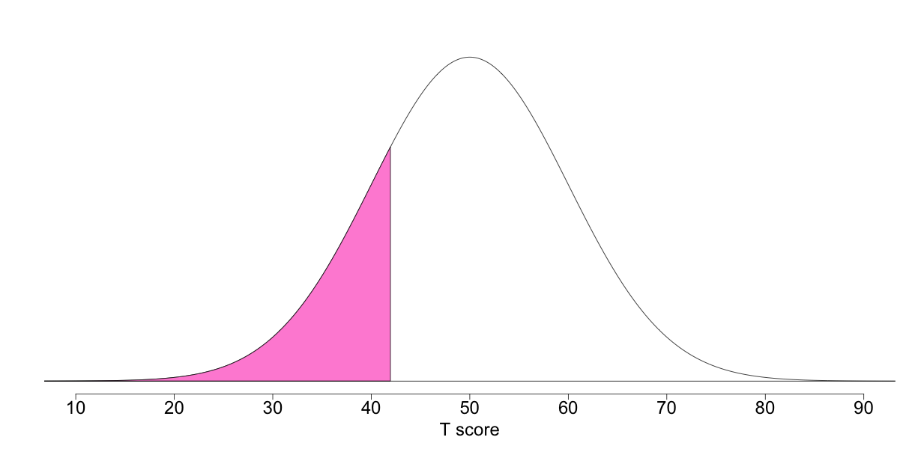

[click for more info about reading this image](https://sapa-project.org/survey/report.php)

Your score on the Intellect scale indicates that you are somewhat less interested in philosophical concerns. While you might pick up some things quickly, other topics might require more time (perhaps because you are not really interested). It is likely that in general, you take a more careful or thorough approach to learning and spend longer sorting out your thoughts and planning your words. This may mean that when you arrive at your final conclusion, it is more polished and coherent than it would be otherwise.

"We should take care not to make Intellect our God; it has, of course, powerful muscles, but no personality."  
— Albert Einstein

### Click here to SHOW/HIDE the rest of your TWO: SPI-27 scores. [Click before you copy top to bottom of your results to make a MS Word copy!!]

### ****Easy-Goingness****

Easy-Goingness relates to one's preferred pace of lifestyle. Whereas individuals who score highly in the Easy-Goingness trait are content to let life proceed at its own pace, those who score low tend to prefer to grab life by the horns. Whereas in some cultures someone who is high in Easy-Goingness may be criticized as lazy or lay-about, in others such an individual is perceived as being content with the way they live their lives. Similarly, someone low in Easy-Goingness could be described as either a go-getter or as overly high-strung.

**Your score of 58 on Easy-Goingness places you higher than 79% of previous participants in this survey.**

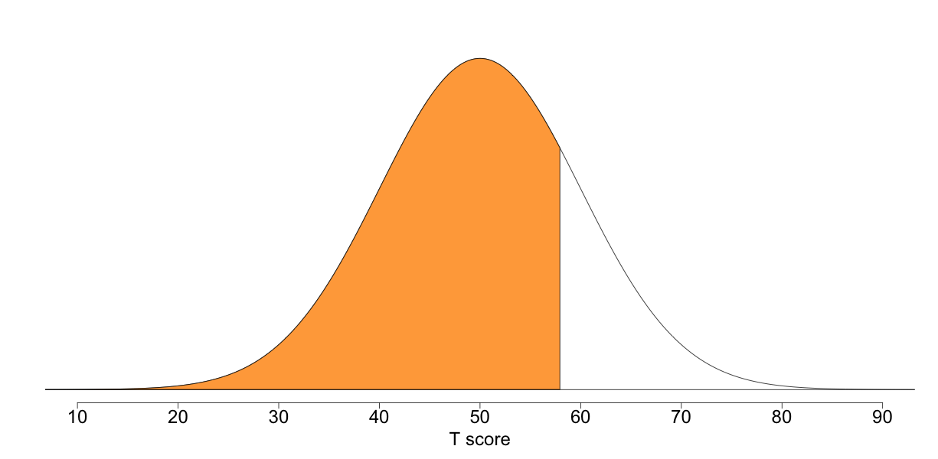

[click for more info about reading this image](https://sapa-project.org/survey/report.php)

Your score on the Easy-Goingness scale indicates that you are fairly high in Easy-Goingness. More than most, you are able to enjoy relaxation and life's simple pleasures, and to relax even when things are bustling around you. You are probably more amenable to taking things slow and easy, and feel less of a need to force things to run more efficiently. But this doesn't mean that you laze about all the time or that you never get anything done... more likely, you take your leisure seriously and are better at establishing work-life balance.

"The greatest happiness is doing nothing"  
— Zhuangzi

### ****Well-Being****

Well-Being is something that many people around the world covet and even see as life's ultimate goal — countless self-help materials have been developed with the intention of aiding people in this respect. Individuals who are high in Well-Being tend to feel good about themselves and their lives. They typically feel comfortable with who they are, and rarely experience feelings of worthlessness or hopelessness. This positive attitude towards oneself may confer a variety of benefits, including better relationships, better health, and less stress. Research shows that having perspective and gratitude can result in greater Well-Being. Those scoring low in Well-Being may have more difficulty enjoying what life has to offer.

**Your score of 57 on Well-Being places you higher than 76% of previous participants in this survey.**

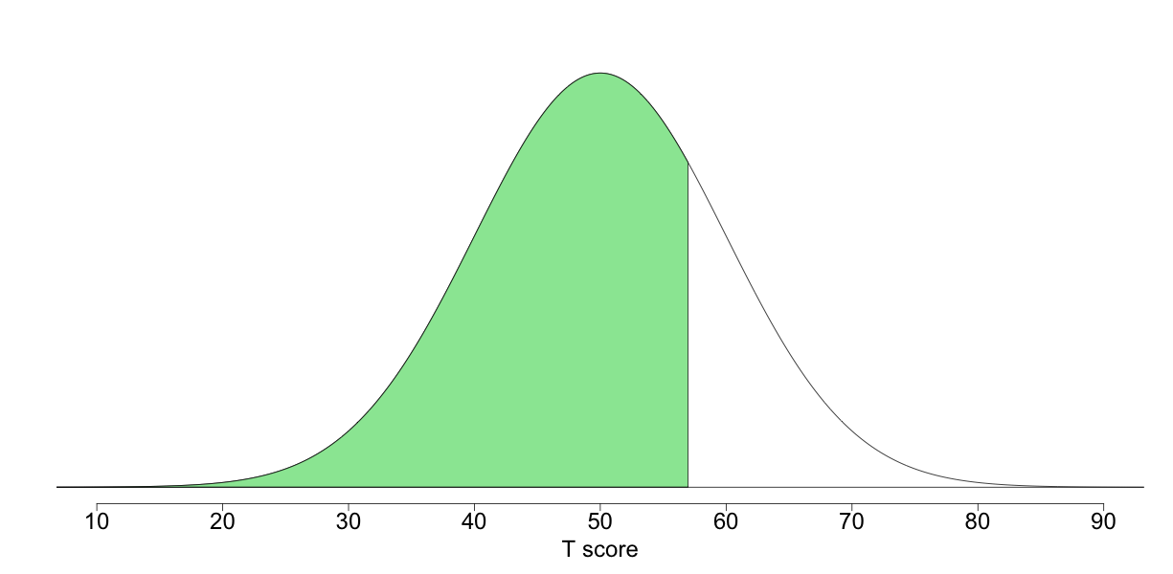

[click for more info about reading this image](https://sapa-project.org/survey/report.php)

Your score on the Well-Being scale indicates that you are somewhat high in Well-Being. You remain generally positive without being an excessive optimist. You are less likely to be complacent in your well-being and more cognizant of the daily work of maintaining it.

"Happiness is letting go of what you think your life is supposed to look like and celebrating it for everything that it is."  
— Mandy Hale

### ****Creativity****

The Creativity scale measures one's tendency to come up with new and different ideas, as well as one's interest in breaking from the mold and following less trodden paths, whether through work or hobbies. Creativity is not the same thing as intelligence, but rather a particular mode of thinking and expression. Individuals high in Creativity may be better at more creative jobs that allow room for creative expression than those which are heavily structured. They may also be better at divergent thinking, which entails coming up with multiple solutions to a single problem. This is distinguished from convergent thinking, which involves finding the single correct answer to a problem. Individual's lower in Creativity are by no means necessarily less smart, but may simply have more respect for previously established modes of thinking and an appreciation for simplicity and tradition.

**Your score of 57 on Creativity places you higher than 76% of previous participants in this survey.**

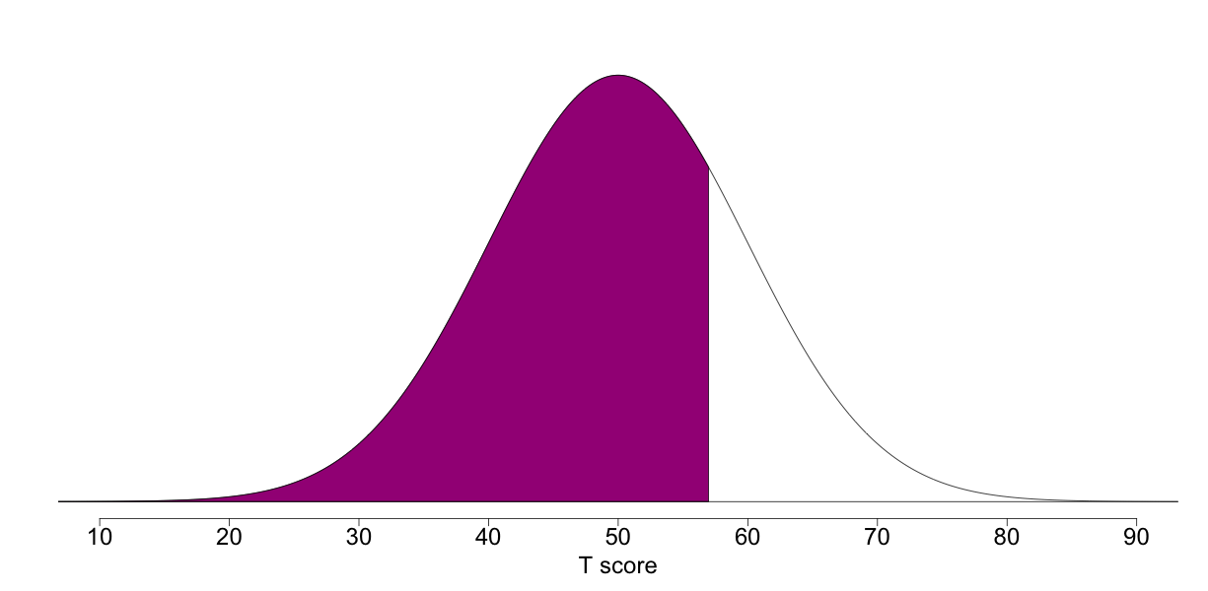

[click for more info about reading this image](https://sapa-project.org/survey/report.php)

Your score on the Creativity scale indicates that you are fairly high in Creativity. It is likely that you often think outside the box and find yourself coming up with new and interesting ideas. People may turn to you when they need a fresh perspective. At the same time, your penchant for novel thinking may make it more frustrating for you to perform mundane tasks or to do work that doesn't allow for creative expression.

"Creative thinking inspires ideas. Ideas inspire change."  
— Barbara Januszkiewicz

### ****Humor****

People often rank Humor highly among the traits that they value in a potential romantic partner or friend. Individuals high in humor may be popular as a result of the mirth they spread around freely. They are likely less restrained in showing that they think something is funny, and more likely to keep a situation light and enjoyable through either their own jokes or their enthusiastic approval of others' jokes. However, individuals scoring low in humor are not necessarily dour... in fact, they may even have a very good internal sense of humor that they simply express less openly or express only to those close to them. Or, they might be more likely to express their humor through writing or art than through verbal laughter or loud jokes.

**Your score of 43 on Humor places you higher than 24% of previous participants in this survey.**

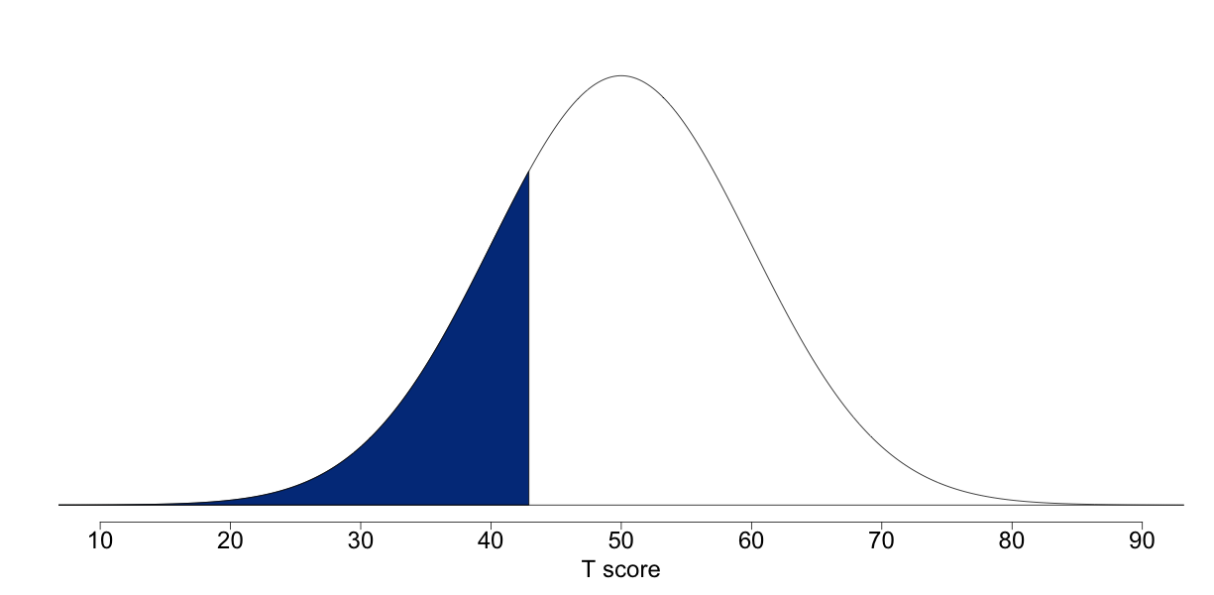

[click for more info about reading this image](https://sapa-project.org/survey/report.php)

Your score on the Humor scale indicates that you are somewhat less likely to joke around or to laugh openly and frequently. You might have a more serious outlook on life, which could be due to an awareness of life's harsh realities or the need to bear a lot of responsibility. This doesn't mean that you can't enjoy a good joke. It's simply that you're less likely to guffaw loudly, or to get up on a table and dance just to entertain people.

"When comedy fails, seriousness begins to leak back in."  
— Susan Sontag

### ****Conformity****

The Conformity factor concerns an individual's self-perception of normalcy, as well as their desire to be seen as an ordinary or average person. The pressure to conform is strongly connected to group acceptance, and can emanate from many sources, including mainstream media, social institutions, families, and peers. In many cultures, being "normal" often means that one is more readily accepted and therefore likely able to access shared resources of both tangible and immaterial nature. An individual high in Conformity may feel these pressures more keenly and have more of a desire to feel and be seen as normal. They typically have less interest in sticking out or in flaunting their differences. They probably feel more comfortable finding common ground with others and identifying with the interests of others. Conversely, an individual who is low in Conformity strives to be unique and would hate to be seen as ordinary or mainstream. They may pride themselves on thinking and acting outside the box.

**Your score of 57 on Conformity places you higher than 76% of previous participants in this survey.**

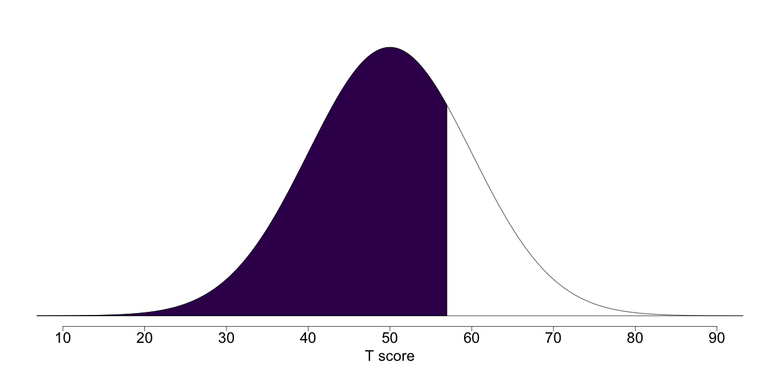

[click for more info about reading this image](https://sapa-project.org/survey/report.php)

Your score on the Conformity scale indicates that you are fairly high in Conformity. Most likely, you are generally comfortable following common standards for behavior. This may be because you have come to believe that this is often the easiest way to proceed in life, and it is also often helpful in facilitating social connections. You are probably not commonly found deviating from social norms or rocking the boat, and others may perceive you as relatable and reliable. That being said, it is also possible that you are not entirely unwilling to set yourself apart from others if the situation calls for it.

"The lamps are different, but the light is the same."  
— Rumi

### ****Sociability****

Sociability relates to behaviors that are predictable given the name of the trait — individuals who are highly sociable prefer to be around other people much more than being alone. Of course, humans are social animals so most individuals do not like to go long periods of time without social contact of one form or another. Individuals differ however in terms of the extent to which they can handle large crowds or nearly constant socialization. Individuals who are low on Sociability prefer small groups and may even prefer to be alone most of the time. Those who are high on Sociability think of themselves as alone when working in a loud coffeeshop and prefer to be surrounded by large groups of friends. Sociability is a hallmark of Extraversion so it is no surprise that it is moderately-to-strongly correlated with the traits of Sensation-Seeking (.4), Attention-Seeking (.5), and Charisma (.5). But it is also positively correlated with a sense of well-being, likely due to humans' strong need for social support and friendship.

**Your score of 43 on Sociability places you higher than 24% of previous participants in this survey.**

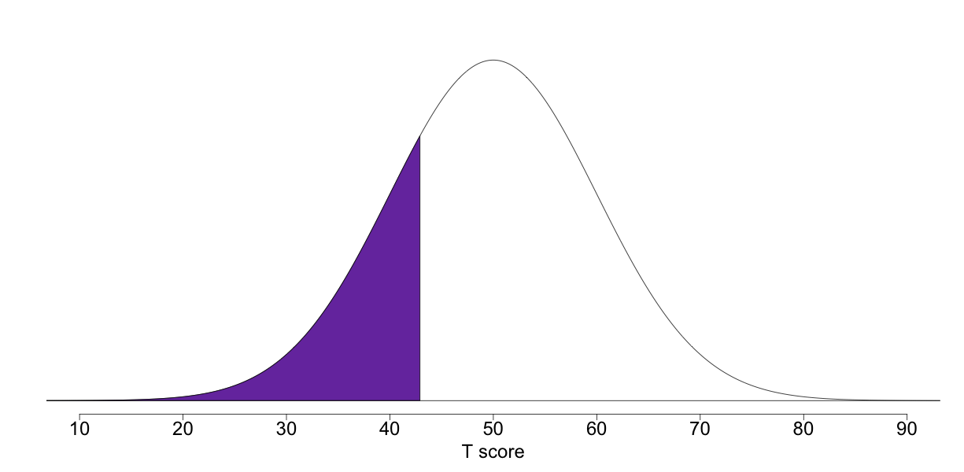

[click for more info about reading this image](https://sapa-project.org/survey/report.php)

Your score on the Sociability scale indicates that you are somewhat low in Sociability. You may rarely enjoy large parties, but it depends on the circumstances and your energy level. More likely, you prefer the company of a few friends, especially those who you know quite well. You probably don't spend much time chatting with people you've never met and you probably don't care much for big crowds.

"Being alone has a power that very few people can handle."  
— Steven Aitchinson

### ****Honesty****

The Honesty dimension relates mainly to the behaviors of cheating or lying, but it also extends more generally to include one's willingness to take advantage of others for their own benefit. Individuals who are less honest would be more likely, for example, to deceive others or cut corners when there are no perceived consequences (and maybe even when there are consequences). Highly honest individuals, on the other hand, are more likely to uphold social norms about stealing, cheating, and acting in good faith in interpersonal relationships. Of course, the social demands for honesty are quite high and, ironically, dishonest individuals may be relatively unlikely to respond openly to items about lying and cheating. The feedback provided here is based on the answers you gave, so the accuracy of your scores will reflect the degree to which you were honest with yourself!

**Your score of 56 on Honesty places you higher than 73% of previous participants in this survey.**

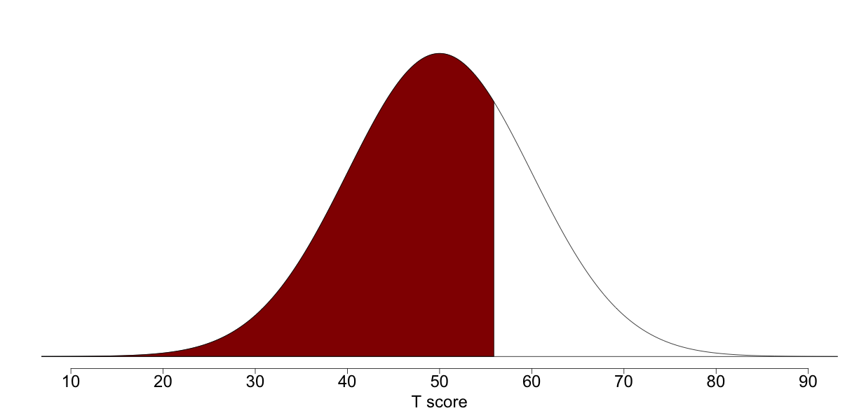

[click for more info about reading this image](https://sapa-project.org/survey/report.php)

Your score on the Honesty scale indicates that you are somewhat high in Honesty. Being truthful is important to you so you rarely lie or cheat to get ahead. It is also rare that you will consciously take advantage of someone for your own ends. You probably do your best to be fair and stick to your word. You may be disappointed from time to time by others who fail to uphold the same standards but you also recognize that some people value honesty less than their own success in life.

"No legacy is so rich as honesty."  
— Shakespeare, 'All's Well That Ends Well'

### ****Industry****

Industry is characterized by the virtues of diligence and perseverance and industrious individuals tend to be hard-working, efficient, and reliable. When given a task, they typically get to work right away and make a point of completing the task promptly and successfully. Given their strong work ethic, industrious people tend to be pre-occupied, at times, with tasks that less-conscientious individuals do not value. Less industrious individuals are not necessarily unproductive, but they do tend to be more laid back and more easily disinterested when the going gets tough.

**Your score of 44 on Industry places you higher than 27% of previous participants in this survey.**

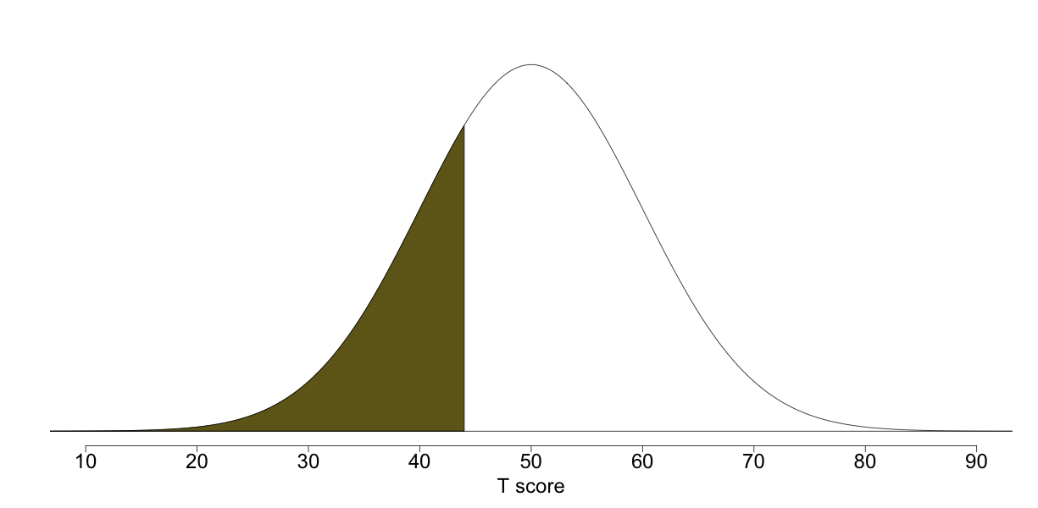

[click for more info about reading this image](https://sapa-project.org/survey/report.php)

Your score on the Industry scale indicates that you are somewhat lower than average in industriousness. This suggests that you have a reasonable balance between working and enjoying yourself. While you may view yourself as a relatively dependable worker, you also probably don't consider your work (or schoolwork) to be the most important factor in your life. You may waste a little too much time occasionally but you typically get important tasks done when you need to.

"All work and no play makes Jack a dull boy."  
— James Howell

### ****Emotional Expressiveness****

The Emotional Expressiveness factor involves the degree to which an individual is comfortable sharing their feelings, perspectives, and experiences with others. Emotional expressiveness is related to emotion regulation, though the nature of this relationship can be complicated. Those who are emotionally expressive tend to be more aware of how they're feeling, and it is generally believed that higher levels of expression are helpful for emotion regulation. It may also be the case however that excessive emotional expression (or emotional expression that is not well-received by others) can be counter-productive for emotion regulation. Individuals who are high in Emotional Expressiveness are less inhibited about showing their emotions in front of others, and may be less concerned with how others perceive them. Individuals low in Emotional Expressiveness typically feel more pressure to keep up an appearance of emotional stability, and may be more guarded in showing their true feelings.

**Your score of 45 on Emotional Expressiveness places you higher than 31% of previous participants in this survey.**

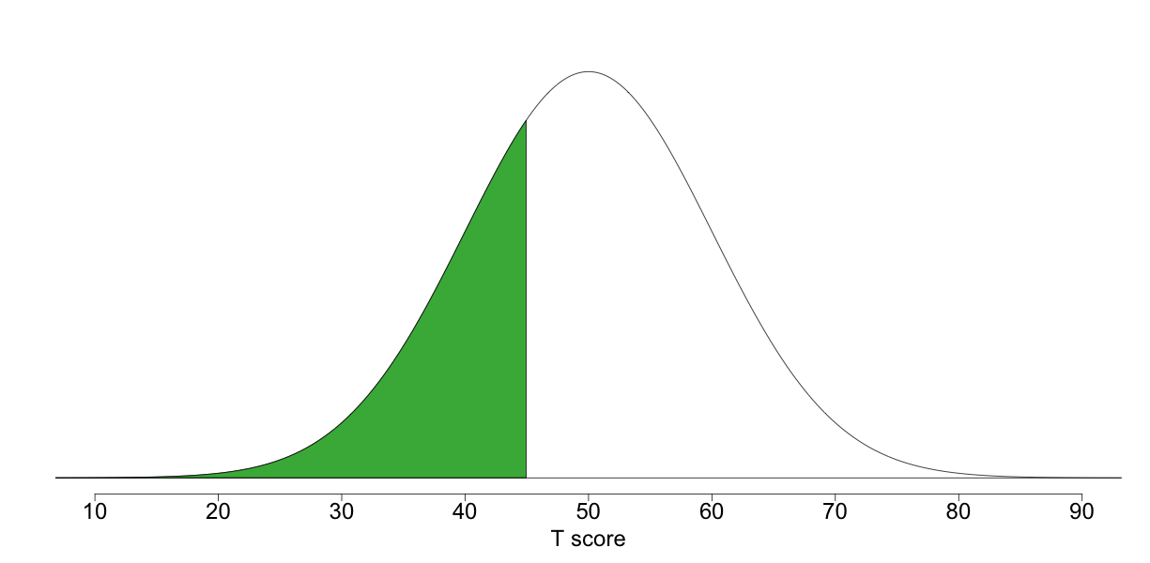

[click for more info about reading this image](https://sapa-project.org/survey/report.php)

Your score on the Emotional Expressiveness scale indicates that you are somewhat low in Emotional Expressiveness. Most likely, you are a bit more guarded about sharing your feelings and revealing information about yourself. It may be that you are wary of burdening others with your negative feelings, or that you just don't feel comfortable talking about your emotions. While you may be much more open with others after you get to know them a little, they will probably have to earn your trust before you're comfortable revealing your true self.

"The world is a tragedy to those who feel, but a comedy to those who think."  
— Horace Walpole

### ****Emotional Stability****

An Emotionally-Stable individual is not easily disturbed by daily hassles and recovers quickly when more substantial stressors inevitably occur. Emotional stability is not necessarily synonymous with consistent positivity, but simply implies lower levels of reactivity. This trait is sometimes used to describe the opposite end of the trait of Neuroticism, though the latter tends to include a broader range of individual differences. The key to Emotional Stability, as the name suggests, is the degree and speed with which moods shift. Those who are high in stability are better able to endure stress without getting flustered. Those who are low, by contrast, will experience more fluctuating moods as they go about their day.

**Your score of 55 on Emotional Stability places you higher than 69% of previous participants in this survey.**

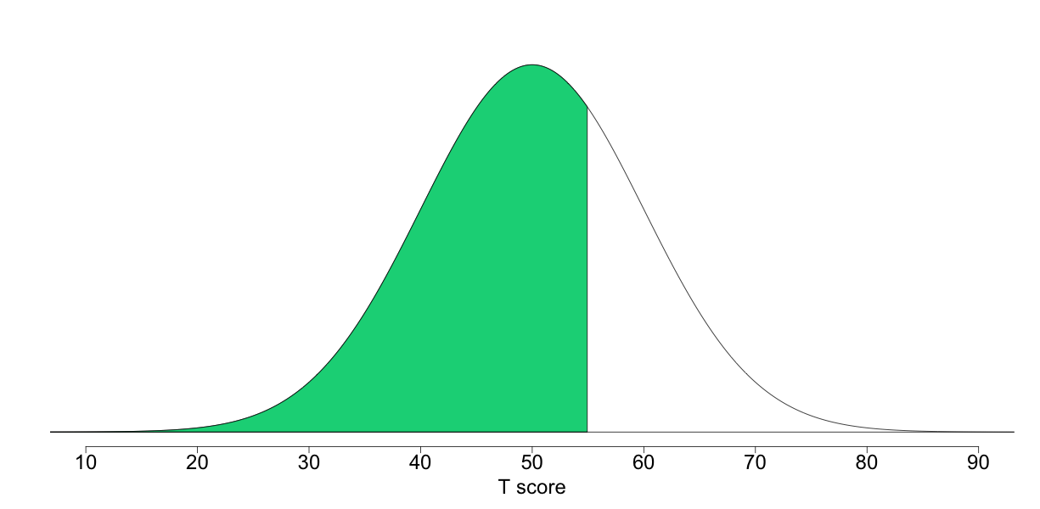

[click for more info about reading this image](https://sapa-project.org/survey/report.php)

Your score on the Emotional Stability scale indicates that you are somewhat high in stability. You are probably less easily upset or emotionally reactive, and you may handle daily hassles better than most. Although you probably get agitated from time to time, you are more likely to deal effectively and coolly with frustrating or threatening situations. Due to your controlled reactions, at times others may find you cold or aloof. Emotionally stable individuals tend to be more calm and free from persistent negative feelings. Freedom from negative feelings does not mean that these individuals experience more positive feelings than others, but they are less likely to experience frequent mood swings or be shook up by negative events. Some emotionally stable individuals may go so far as to seek out thrilling situations, such as scary movies and roller-coasters, because they perceive these situations to be less threatening than most people.

"When stability becomes a habit, maturity and clarity follow."  
— B.K.S. Iyengar

### ****Introspection****

Introspection is a factor concerning one's tendency to turn thoughts inward and onto oneself, as well as one's efforts to grapple with understanding the world more deeply. Individuals high in Introspection may find themselves drifting off into spirals of thought as they consider things about life and try to understand their role within everything. They may be less content with existing explanations for different phenomena. Individuals low in Introspection may prefer to stay focused on what is in front of them and not to concern themselves over what is invisible or abstract. They may rely more on an intuitive understanding of the world and therefore feel less of a need to delve into things or to ruminate and reflect.

**Your score of 55 on Introspection places you higher than 69% of previous participants in this survey.**

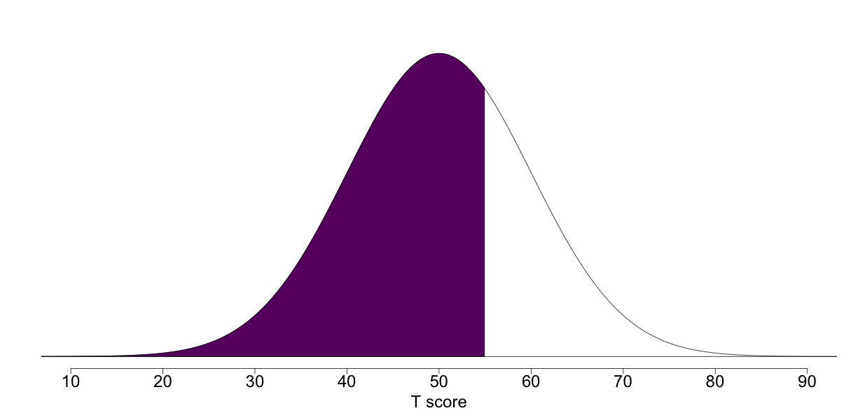

[click for more info about reading this image](https://sapa-project.org/survey/report.php)

Your score on the Introspection scale indicates that you are fairly high in Introspection. Most likely, you find yourself at times lost in thought as you reflect on yourself and on various aspects of life. You may enjoy delving deeper and contemplating human existence. It is also possible that you seek insight on how to improve as a person, and on how to best to live life. You find yourself ultimately accessing wisdom as you reflect and pierce through the surface of things.

"A moment's insight is sometimes worth a life's experience."  
— Oliver Wendell Holmes

### ****Attention-Seeking****

Despite the connotations that are often associated with Attention-Seeking, it is not necessarily a narcissistic or negative trait. Rather, Attention-Seeking can be motivated by a variety of concerns, including a desire to please people by making them happy or entertained. Those who are more sociable, humorous and charismatic often take center stage at social gatherings, for example, so it should be no surprise that Attention-Seeking is most highly correlated with those traits. It is true of course that those high in Attention-Seeking sometimes put on a show to impress others and this behavior is sometimes perceived as self-serving. Attention-seeking behavior is often quite effective and this means that individuals who are high in this trait are often perceived as being more popular and having more social connections. Individuals low in Attention-Seeking prefer to be on the sidelines and out of the spotlight. This sometimes allows them to be more observant of what is going on around them. Though they are less likely than those high in Attention-Seeking to be noticed or immediately admired, they are not necessarily misanthropic or without social skills. They may simply prefer social interactions in which all parties contribute on a roughly equal level.

**Your score of 46 on Attention-Seeking places you higher than 34% of previous participants in this survey.**

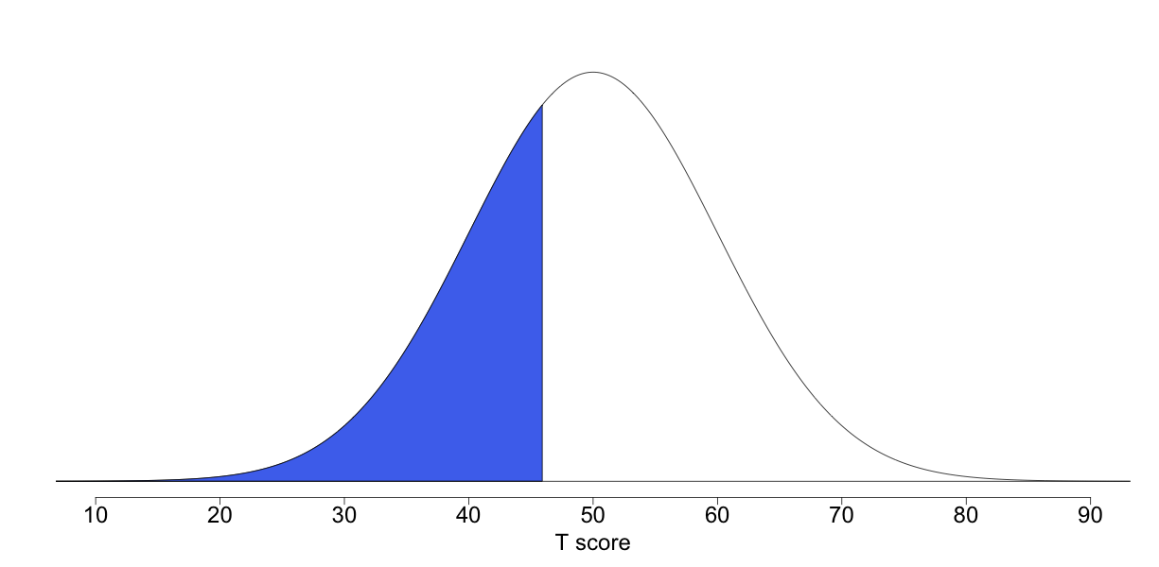

[click for more info about reading this image](https://sapa-project.org/survey/report.php)

Your score on the Attention-Seeking scale indicates that you are somewhat low on Attention-Seeking. Most likely, you do not actively try to attract the attention or approval of others. Because of this, you may find yourself observing others instead of commanding their attention. It is possible that you dislike the sort of posturing that comes with trying to win large groups of people over, and prefer to be more of a bystander or to engage in more personal social interactions. That being said, you may not necessarily be opposed to entertaining others or leading a group if the situation calls for it.

"Showing off is the fool's idea of glory."  
— Bruce Lee

### ****Anxiety****

Anxiety is something that many people struggle with. It's difficult to escape entirely, as most people typically feel anxiety when put into stressful situations. A little anxiety has been shown to provide a useful boost in motivating people to perform well or to change their behavior if necessary. But at its most extreme, anxiety can get in the way of daily living and make an individual fearful of engaging in various situations. Anxiety can be generalized (involving a more distributed sense of foreboding or malaise) or specific to certain conditions, such as social engagement or test-taking. For individuals who find that anxiety creates problems in living, various therapies and interventions are available to encourage more positive thinking and make it easier to understand, process, and manage anxious feelings.

**Your score of 47 on Anxiety places you higher than 38% of previous participants in this survey.**

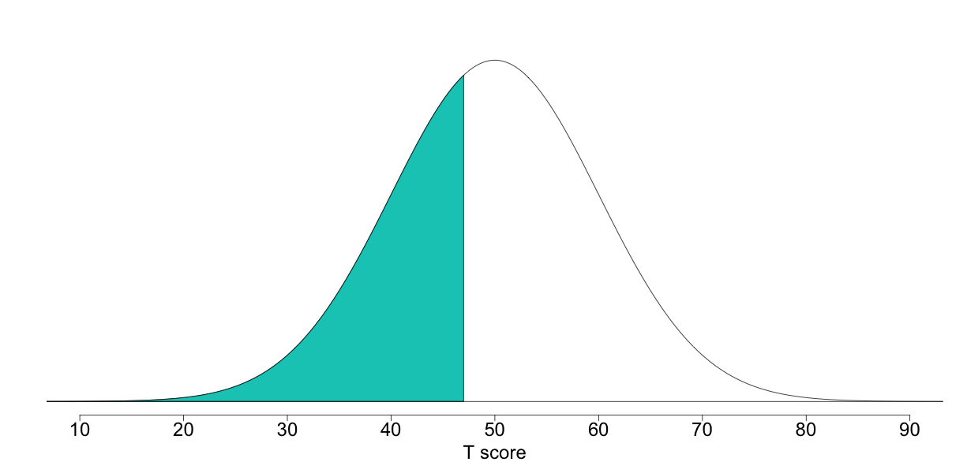

[click for more info about reading this image](https://sapa-project.org/survey/report.php)

Your score on the Anxiety scale indicates that you are somewhat less likely than average to feel anxious. Even in situations which might make other people nervous or worried, you most likely manage to keep your cool. While this doesn't necessarily mean that you never feel anxious, it does mean that you are relatively more skilled at regulating your thoughts and emotions when it comes to situations that make others nervous or worried.

"Why worry? If you've done the very best you can, worrying won't make it any better."  
— Walt Disney

### ****Perfectionism****

The Perfectionism factor is one of the most intuitive to understand — it can be explained simply as an individual's desire for perfection. An individual high in Perfectionism will likely set high expectations and then expect those to be met, by themselves and others. Perfectionists notice many errors and flaws, and are therefore often hard to satisfy. Their work may be of an especially high standard, but those around them feel pressured as they strive to meet expectations. At its most extreme, Perfectionism has the potential to cause difficulties in relationships. Individuals low in Perfectionism feel less need to aspire to lofty standards, and are more content with getting to the point of "good enough" and leaving it at that. They may have more ease in letting go of one project and moving on to the next than those high in Perfectionism.

**Your score of 52 on Perfectionism places you higher than 58% of previous participants in this survey.**

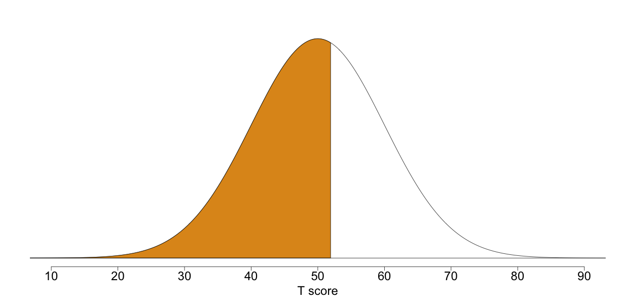

[click for more info about reading this image](https://sapa-project.org/survey/report.php)

Your score on the Perfectionism scale indicates that you are fairly high in Perfectionism. Most likely, you pride yourself on completing excellent work and in achieving success in other areas as well. At work, people may feel comfortable handing off an assignment to you which requires close attention to detail. At the same time, you may take pains not to become too neurotic in your desire to do good work or to achieve fulfillment in other areas of life. You may realize that certain things are necessarily out of your hands, and subsequently that agonizing over things needlessly is ultimately fruitless.

"You cannot invest your soul in a compromise."  
— David Emerald

### ****Order****

Orderliness is generally valued as an aspect of personality because it is suggestive of tendencies towards organization, predictability, and cleanliness. Like all traits however, it is not true that more orderly behavior is always better. An excessive desire for order can lead to perfectionistic behaviors and unrealistic expectations. In extreme cases, the inability to tolerate even small amounts of disorder may be associated with mental health issues. Orderliness scores tend to be positively correlated with Industry and Perfectionism but are negatively correlated with Sensation-Seeking and Easy-Goingness.

**Your score of 52 on Order places you higher than 58% of previous participants in this survey.**

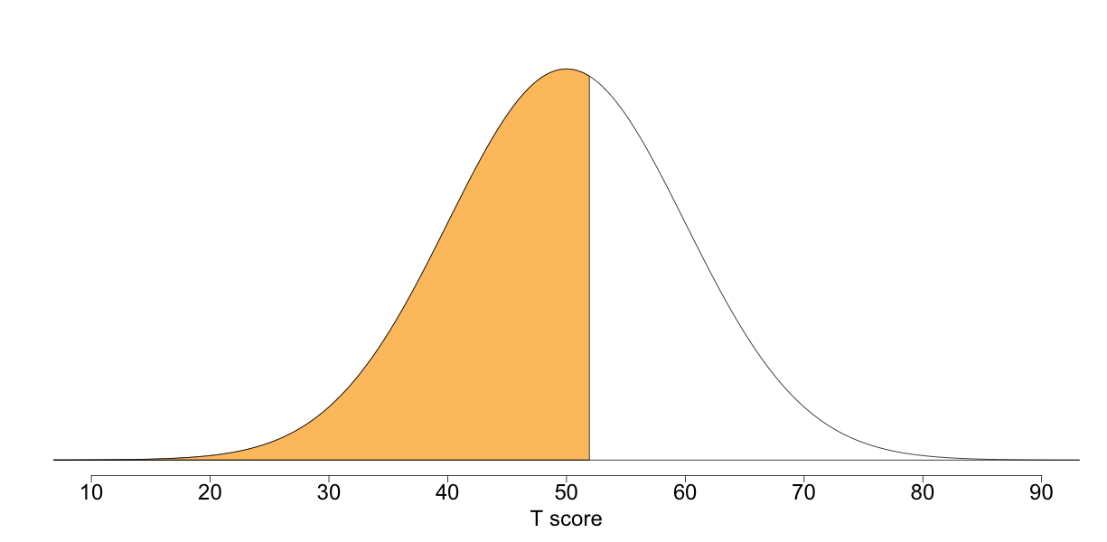

[click for more info about reading this image](https://sapa-project.org/survey/report.php)

Your score on the Order scale indicates that you are somewhat high in orderliness. While details are important to you, you're willing to let things slide sometimes. You likely prefer order and regularity in your work and surroundings but you are not insistent on perfection. You also probably recognize that there are many aspects of life that simply cannot be controlled so there's no point in getting too worked up about it.

"Outer order contributes to inner calm."  
— Gretchen Rubin

### ****Conservatism****

The Conservatism factor brings together a number of attitudes which often, though not always, relate to each other. These include, perhaps most obviously, a tendency to support conservative politics and a strong nationalistic patriotism, but may also involve religiosity. Typically, individuals who score low in Conservatism tend to be less religious-minded and tend to vote for liberal political candidates. They may be less nationalistic than others. This dimension is also highly correlated with one's stance on related issues, such as the military, the role of government, the importance of national security, welfare, gun ownership, business, fiscal responsibility, and various values.

**Your score of 49 on Conservatism places you higher than 46% of previous participants in this survey.**

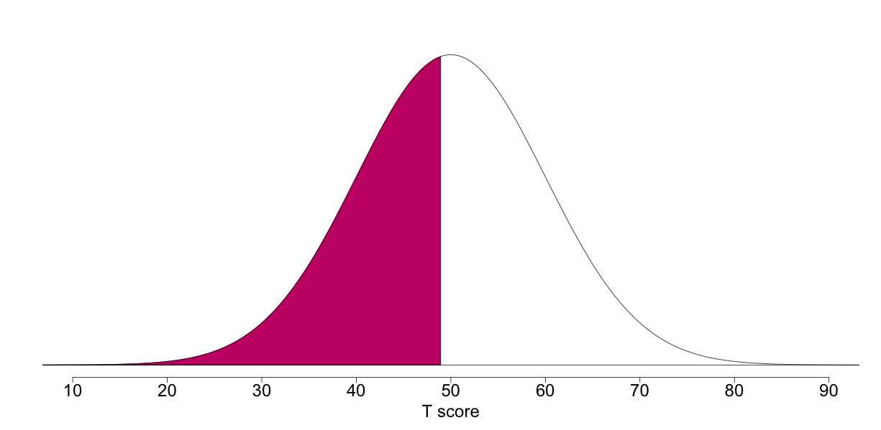

[click for more info about reading this image](https://sapa-project.org/survey/report.php)

Your score on the Conservatism scale indicates that you are somewhat lower in Conservatism. You may be more likely to support liberal candidates and less likely to be religious or nationalistic. Depending on your personal background and the country you live in, this may also mean that you lean towards supporting civil rights issues, place more faith in welfare programs, and are wary of traditional social roles and military expenditure, among other things. But as you don't lean too heavily in one political direction, it is possible that you are sometimes able to find more ideological common ground with conservatives.

"A liberal is a man or a woman or a child who looks forward to a better day, a more tranquil night, and a bright, infinite future."  
— Leonard Bernstein

### ****Compassion****

Individuals who are high in Compassion are likely to be perceived as warm and caring individuals who enable others to feel at ease in their presence. Although the draw to people high in Compassion is different from the draw to people who are charismatic or powerful, compassionate people are welcome friends who help those around them to feel cared for and understood. Compassion is particularly important in the development and maintenance of positive social relationships and there is a growing body of evidence that these are crucial for well-being across the lifespan. For this reason, Compassion is viewed by many as an important component of a happy life.

**Your score of 49 on Compassion places you higher than 46% of previous participants in this survey.**

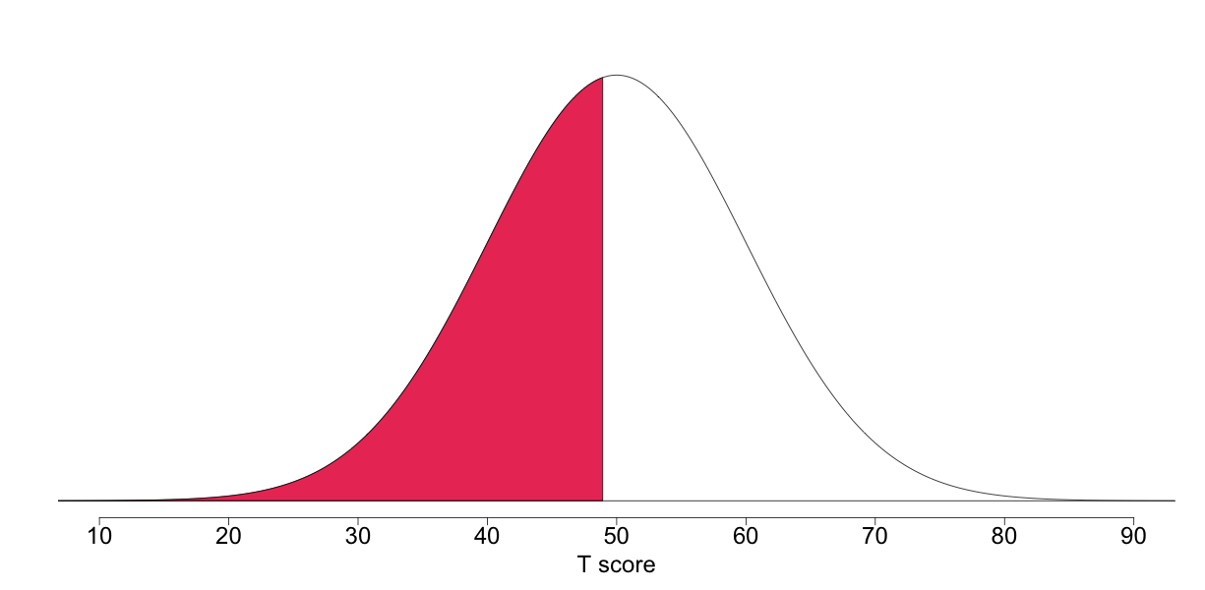

[click for more info about reading this image](https://sapa-project.org/survey/report.php)

Your score on the Compassion scale indicates that you are a bit less focused on the feelings and needs of others. It may simply be that the conditions of your life require you to attend to your own needs first and foremost! It is likely that although you don't shut other people out entirely, you believe that most people are equipped to take care of themselves. People probably know not to badger you with personal or emotional requests. Even if you see a sad movie, you are less likely to empathize with the characters to the point of being moved to tears.

"Put on your own oxygen mask before helping others."  
— Randy Pausch, 'The Last Lecture'

### ****Self Control****

Self-Control is a measure of a person's ability to control their short-term desires, often for the sake of long-term benefit. This can involve an individual's adeptness at controlling cravings, or by the same token the frequency with which an individual finds themselves succumbing to temptation. Individuals high in Self-Control have an easier time holding themselves back from something that might cause them trouble in the long run. Individuals who score lower will often find themselves splurging, and may adopt a policy of "act now, figure it out later" when faced with something enticing. Ultimately, they ascribe to a more hedonistic lifestyle, and may see less point in delaying pleasure. Many people wonder how Self-Control and Impulsivity are related. They tend to have a moderate negative correlation (about -0.4). Self-Control relates more to the resistance of urges, temptations and cravings whereas Impulsivity more generally reflects acting before thinking.

**Your score of 51 on Self Control places you higher than 54% of previous participants in this survey.**

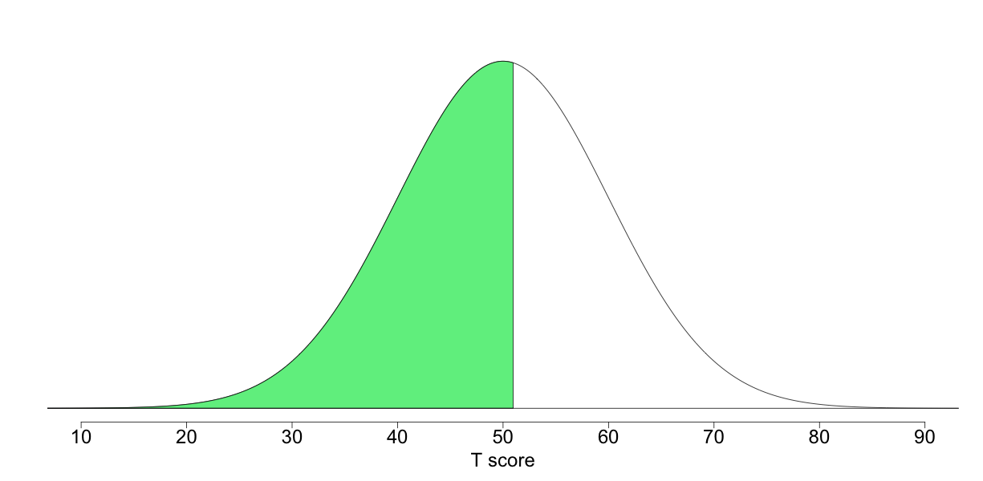

[click for more info about reading this image](https://sapa-project.org/survey/report.php)

Your score on the Self-Control scale indicates that you are fairly high in Self-Control. More than most, you are able to curb your cravings and resist temptation. Even if confronted with something that would be irresistible for most (but unhealthy in the long run), you probably have less difficulty saying no. Your self-discipline and forward thinking may mean that you miss out on more fun in the shorter-term, but that things pay off for you in the long run.

"You have power over your mind — not outside events. Realize this, and you will find strength."  
— Marcus Aurelius

### ****Irritability****

Individuals who are high in Irritability may be more easily rattled by things, whether it be the shortcomings of others, one's environment, or the world in general. This might be due to a lower tolerance for frustration or a sensitivity to unpleasant stimuli. Individuals high in Irritability find themselves frequently bothered by things, often despite their efforts to feel otherwise. Although frequently feeling annoyed doesn't necessarily mean that a person will always show it outwardly or lose their temper, some individuals high in Irritability may be perceived as angrier than the average person. Conversely, an individual who scores low on Irritability may be fairly unperturbed by negative things, although this does not mean that they lack concern regarding what happens in the world.

**Your score of 51 on Irritability places you higher than 54% of previous participants in this survey.**

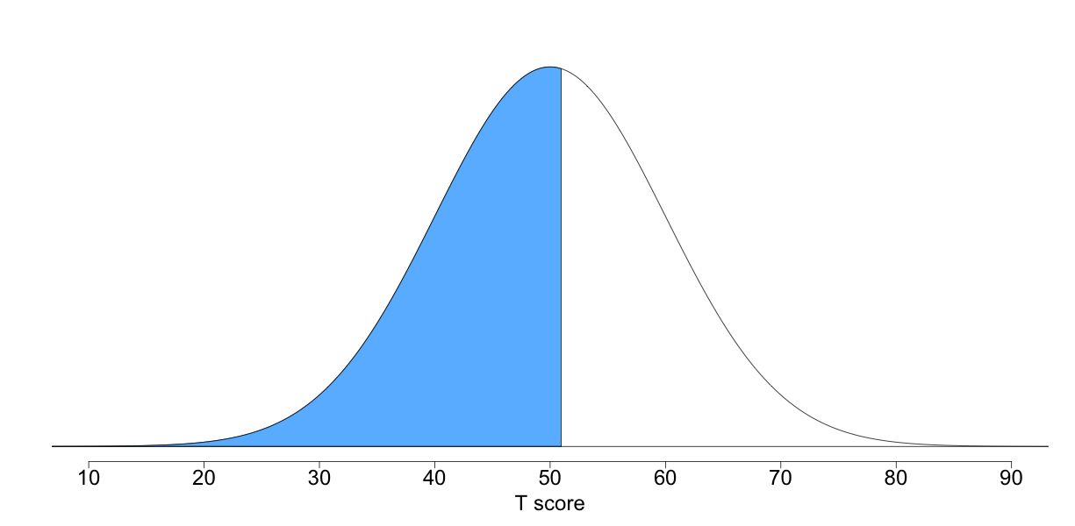

[click for more info about reading this image](https://sapa-project.org/survey/report.php)

Your score on the Irritability scale indicates that you sometimes experience frustration or anger in response to things. This doesn't mean that your annoyance is unreasonable, as it may simply be that you more keenly feel the injustices of the world. There are times when things will bother you enough that you feel upset or get mad, but you are likely not someone who flies off the handle at the drop of a hat.

"You can tell the greatness of a man by what makes him angry."  
— Abraham Lincoln

### ****Art Appreciation****

Art Appreciation involves an individual's interest in works of art and artistic activities. This includes one's attitudes towards poetry, the visual arts, performing arts, literature and more. A person high in Art Appreciation will seek exposure to these topics, though they may not be particularly artistic. Individuals low in Art Appreciation may not feel that art is particularly enticing or relevant to their lives, and likely concern themselves with work or hobbies of a different nature.

**Your score of 51 on Art Appreciation places you higher than 54% of previous participants in this survey.**

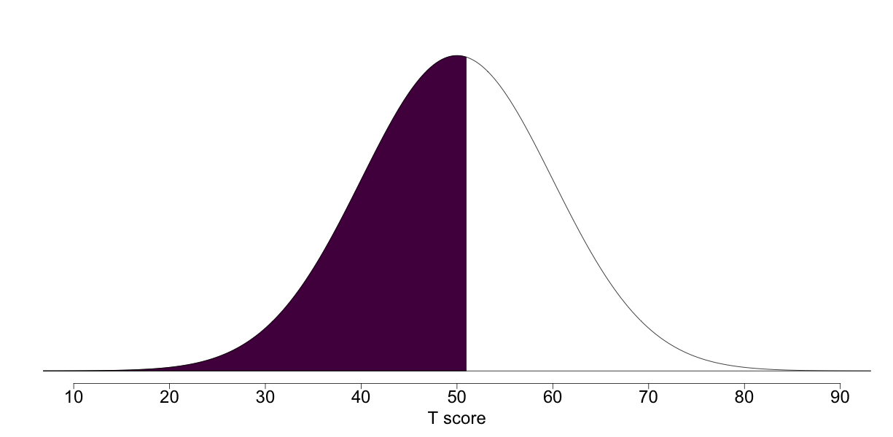

[click for more info about reading this image](https://sapa-project.org/survey/report.php)

Your score on the Art Appreciation scale indicates that you are somewhat high in Art Appreciation. It is likely that the arts are often a part of your life. Whether you are an artist yourself or a supporter, it is probably rare for you to go too long before seeking an artistic outlet, whether by reading a novel, going to an art exhibit, or even creating art yourself. You probably know a fair deal about art and may be viewed by your friends as cultured or artsy.

"Art is the only serious thing in the world."  
— Oscar Wilde

### ****Charisma****

The Charisma scale measures one's adeptness in a range of social situations. Charisma is often described as one of those unusual traits that are hard to define but easy to recognize in others. It is broadly understood as one's skill in handling interpersonal relations and influencing others. It seems to involve a variety of factors including confidence, friendliness, expressive body language, warmth and sincerity. Individuals with unusually high Charisma are social butterflies who rarely seem flustered or disconcerted. They can often seem impressively uninhibited when approaching others or speaking publicly. Individuals low in Charisma often find it difficult to know what to say or do around other people and struggle to get others to see their way. While Charisma often contributes to strong leadership potential, many successful leaders have been notoriously uncharismatic.

**Your score of 50 on Charisma places you higher than 50% of previous participants in this survey.**

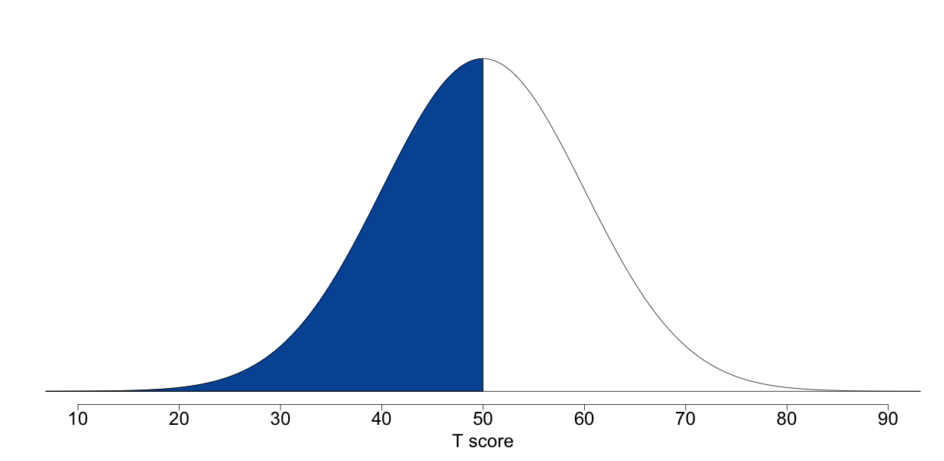

[click for more info about reading this image](https://sapa-project.org/survey/report.php)

Your score on the Charisma scale indicates that you are a fairly charismatic person. You are likely comfortable navigating social situations, and skilled at smoothing situations over. You probably approach others (even strangers) with greater ease than most people. Though even the most charismatic people will feel flustered at times, there are likely many social situations in which you have saved or prevented awkwardness through sheer social grace. Because of your social skills, you may at times even find yourself particularly adept at influencing other people.

"Charisma is the transference of enthusiasm."  
— Ralph Archbold

### ****Sensation-Seeking****

The Sensation-Seeking factor involves one's desire to engage in more adventurous or risky activities. Sensation-Seeking can take a variety of forms; for instance, some individuals who score highly may love scaling mountains but eschew recreational drug use, while others feel the opposite. Individuals high in Sensation-Seeking may feel bored when idle or if they go long stretches with nothing exciting or thrilling to do. Individuals low in Sensation-Seeking derive less pleasure from thrilling activities, often because they find higher levels of arousal unpleasant.

**Your score of 50 on Sensation-Seeking places you higher than 50% of previous participants in this survey.**

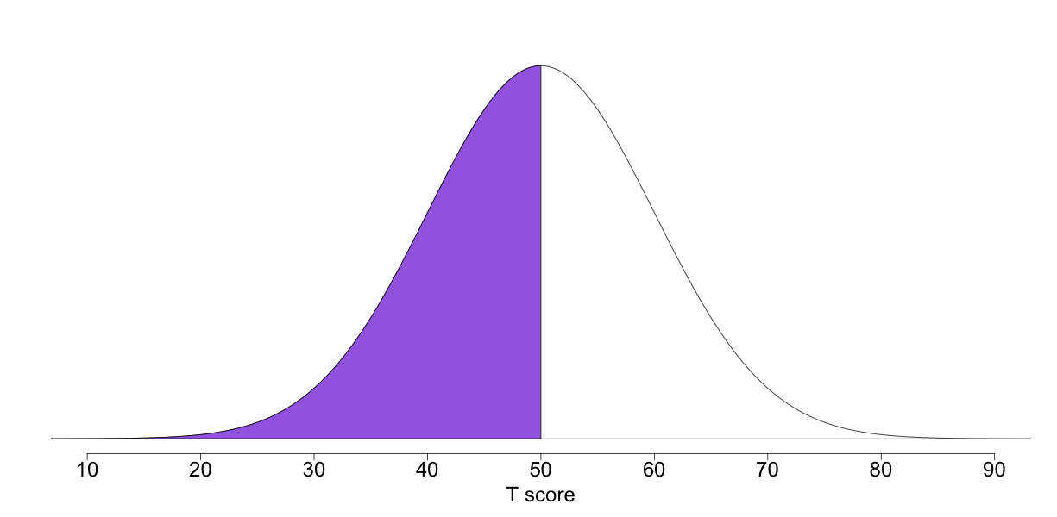

[click for more info about reading this image](https://sapa-project.org/survey/report.php)

Your score on the Sensation-Seeking scale indicates that you are somewhat high in Sensation-Seeking. Most likely, you enjoy activities which involve a fair degree of difficulty and excitement, and crave the feelings of great accomplishment that come with succeeding at them. You may be more willing to take risks or to step up to the plate when others shy away. This approach may enable you to accomplish feats that others would only dream of (though you may also suffer your share of bumps and bruises along the way).

"Life is either a daring adventure or nothing at all."  
— Helen Keller

### ****Authoritarianism****

The Authoritarianism dimension relates to an individual's attitudes about rules and laws. Those high in Authoritarianism typically believe that laws exist for good reason (to keep those who would otherwise transgress in line) and thus should be unequivocally obeyed. To such an individual, authority is crucial to maintaining social order, and rebellious behavior should be nipped in the bud. This belief may be rooted in a more negative view of humanity as naturally unruly and therefore requiring authority to be properly whipped into shape. Those who are low in Authoritarianism believe that strict laws and punishments are not always necessary or useful for reducing crime and improving society. This view is often borne out of concerns that many rules and laws are biased or are not equally enforced among all individuals. While these issues are better suited for political and philosophical forums, the reality is that perspectives on these issues underlie differences in the trait of Authoritarianism. Authoritarianism tends to be moderately positively correlated (0.4) with Conservatism.

**Your score of 50 on Authoritarianism places you higher than 50% of previous participants in this survey.**

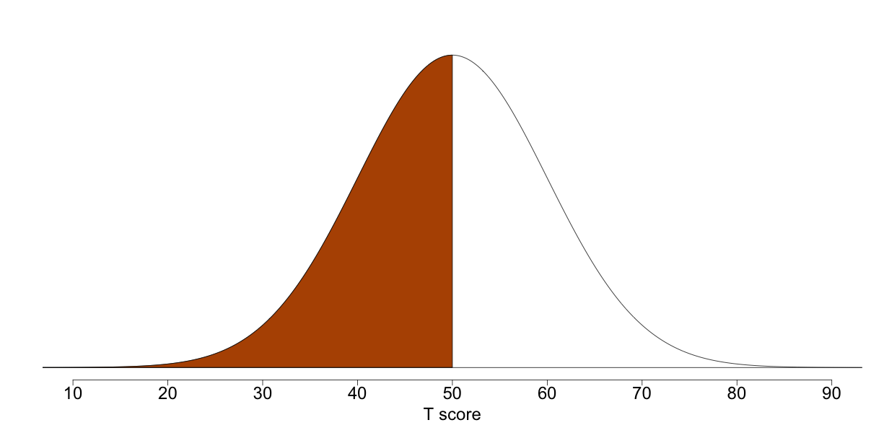

[click for more info about reading this image](https://sapa-project.org/survey/report.php)

Your score on the Authoritarianism scale indicates that you are somewhat high in Authoritarianism. Most likely, you tend towards respecting the law and the authority put in place to enforce it. You probably try to follow the rules and believe that even if laws aren't always perfect, they play an important part in reducing crime and ensuring safety for the greatest number of people.

"We do disagreeable things so that ordinary people here and elsewhere can sleep safely in their beds at night."  
— John Le Carre, 'The Spy Who Came in From the Cold'

**Big Five (SPI-5) Scores**

**All 5 of your Big Five (SPI-5) scores are shown below.**

### ****Agreeableness****

Features of Agreeableness include compassion, trust, honesty, and politeness but the defining characteristic may well be empathy. It seems that the ability to recognize others' emotions contributes to all of these underlying traits as well as many other nuances of personality that are often associated with agreeable people. Agreeableness also reflects individual differences in cooperation and social harmony. While agreeable people are typically more popular than those low on Agreeableness, it is not popularity that motivates them so much as the desire to avoid (or reduce) conflict in their immediate environment. While this quality has several obvious benefits, Agreeableness is not necessarily useful in situations that are highly stressful or that frequently involve tough decisions. As a result, people who feel less need to be agreeable often make excellent scientists, critics, or soldiers.

**Your score of 51 on Agreeableness places you higher than 54% of previous participants in this survey.**

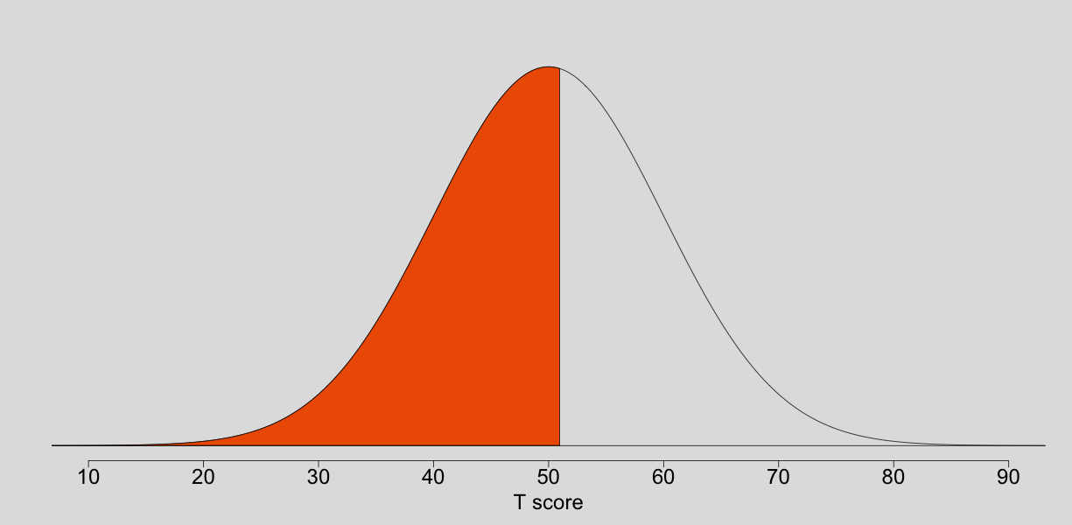

[click for more info about reading this image](https://sapa-project.org/survey/report.php)

Your score on the Agreeableness scale indicates that you are relatively agreeable. You probably have an interest in others' needs and well-being, and you share in both their joys and their challenges. It may be that your compassion is limited to some individuals (perhaps friends and family) without extending to acquaintances or strangers. You are most likely pleasant, sympathetic, and cooperative. You may like doing things for others, especially when they are in need, sometimes even if this puts their needs ahead of your own. It's also likely you are less easily annoyed by others. You may sometimes lose your temper or make insulting judgments about the people with whom you interact, but for the most part you probably avoid judging or criticizing those around you. You can probably receive criticism without holding a grudge. Highly agreeable individuals value getting along with others. They are therefore considerate, friendly, generous, helpful, and willing to compromise their interests for the sake of others. Agreeable people also tend to have an optimistic view of human nature. They believe people are basically honest, decent, and trustworthy.

### ****Conscientiousness****

By definition, a conscientious individual is guided by an inner sense of what is "right" (this inner sense being known as one's "conscience"). While they may hold dramatically different opinions about the nature of socially acceptable behavior, conscientious individuals typically have reputations for being meticulous, thorough, and deliberate. Extreme conscientiousness can lead to unrealistic expectations and perfectionistic behaviors that are ultimately unproductive. Conscientiousness is most highly associated with Industry and Order, though it is also positively correlated with low impulsivity, authoritarian views, honest behavior and strong self-control. Most of these traits relate to self-discipline in one way or another, a feature which likely contributes to the similarity between Conscientiousness and traditional conceptions of "character." While some of the traits within Conscientiousness seem similar enough to be redundant, they generally have unique relationships with other aspects of behavior. For example, Impulsivity relates to the general tendency to act without thinking while Self-Control is the ability to resist temptations and cravings.

**Your score of 52 on Conscientiousness places you higher than 58% of previous participants in this survey.**

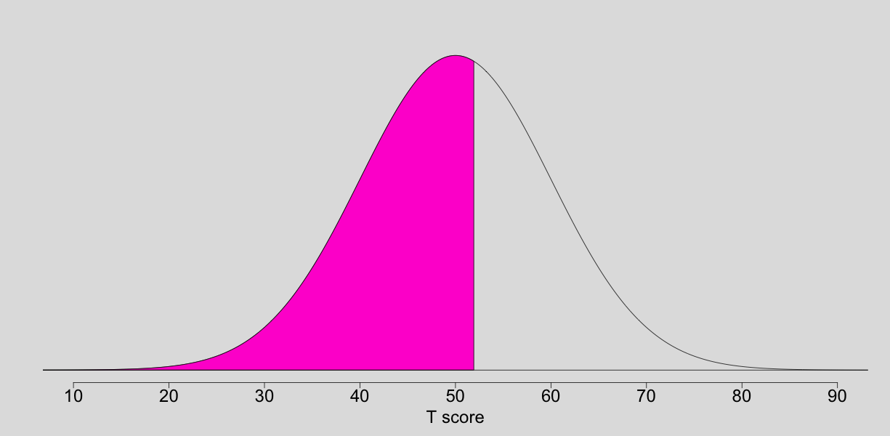

[click for more info about reading this image](https://sapa-project.org/survey/report.php)

Your score on the Conscientiousness scale suggests that you are somewhat conscientious. You probably set clear goals on a regular basis and pursue them with determination. People likely regard you as reliable and hard-working, but probably not overzealous or perfectionistic. You may occasionally prefer to live for the moment and do what feels good now, instead of delaying gratification for the sake of longer-term objectives. You are probably good at detecting mistakes or inconsistencies in your environment. The most conscientious individuals tend to avoid trouble and achieve high levels of success through purposeful planning and persistence. On the negative side, they can be compulsive perfectionists and workaholics. Extremely conscientious individuals are also sometimes regarded as boring, due to their predictability and focus on work.

### ****Extraversion****

Extraversion is perhaps the most widely recognized feature of human personality. The popularized notion of Extraversion is mainly limited to the idea that extraverts seek out social interaction while introverts spend more time alone. Personality theorists suggest that the extraversion/introversion dimension is more accurately framed as a function of stimulation. Individuals who are more sensitive to outside stimuli (introverts) tend to prefer interacting in small groups. They also engage more often in independent, analytical, and cognitively-demanding activities. Extraverts are less sensitive to external stimuli and, as a result, seek more of it. They tend to enjoy large gatherings, act more gregariously, and are quick to assert themselves.

**Your score of 43 on Extraversion places you higher than 24% of previous participants in this survey.**

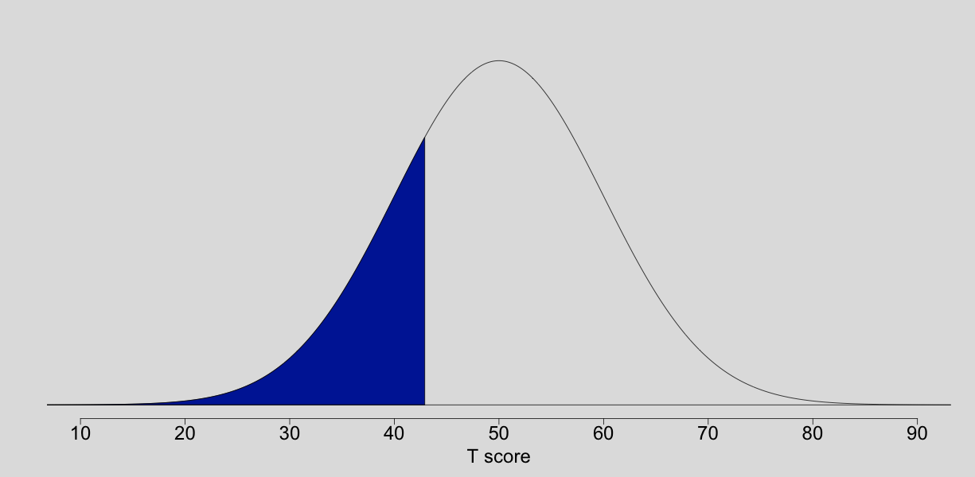

[click for more info about reading this image](https://sapa-project.org/survey/report.php)

Your score on the Extraversion scale indicates that you are somewhat introverted. You are probably more reserved and quiet than most others. You may enjoy solitude and solitary activities a bit more than others, and your socializing may be restricted to a small circle of close friends. While you may occasionally enjoy large parties and meeting new people, it probably depends on the circumstances and your energy level. You are more likely to allow others to take charge so that you can avoid the spotlight, which has the advantage of being seen as less threatening by others. You may not be known as having a strong personality, but most likely you can still be effective at influencing others as long as you have time to gather your thoughts. The occasional avoidance of social interaction by introverts does not necessarily mean they are shy or depressed; these people simply need less stimulation than those who are more extraverted. This independence and willingness to be alone can sometimes be mistaken by others as unfriendliness or aloofness. However, many introverts (especially those who score highly on Agreeableness) are quite pleasant when approached even though they do not actively seek out interaction.

### ****Neuroticism****

The trait of Neuroticism is marked by elevated reactivity to stress and the more frequent experience of emotions that most people view as negative or unpleasant — anxiety, sadness, frustration, fear, and anger. Neurotic individuals view the world as relatively more threatening and dangerous. Historically, use of the label neuroticism (or neurotic, as an adjective) stemmed from the idea that individuals behave in ways that are more or less affected by neuroses — nervous disorders. While the term neurosis is now rarely used by health professionals, the term Neuroticism is still used for the personality trait relating to the persistent tendency to be in a negative mood state. Some people feel that this label is unnecessarily negative, though the truth is that nearly everyone behaves neurotically from time to time and most neurotic behaviors are within socially acceptable limits. Individuals with low levels of neuroticism are less likely to become upset by stress and spend relatively less time feeling worried, scared, and angry — but just about everyone experiences these emotions sometimes. It's no surprise that highly neurotic individuals are at risk for a range of mental health concerns, but more recent research suggests that these risks also extend to several physical health concerns.

**Your score of 45 on Neuroticism places you higher than 31% of previous participants in this survey.**

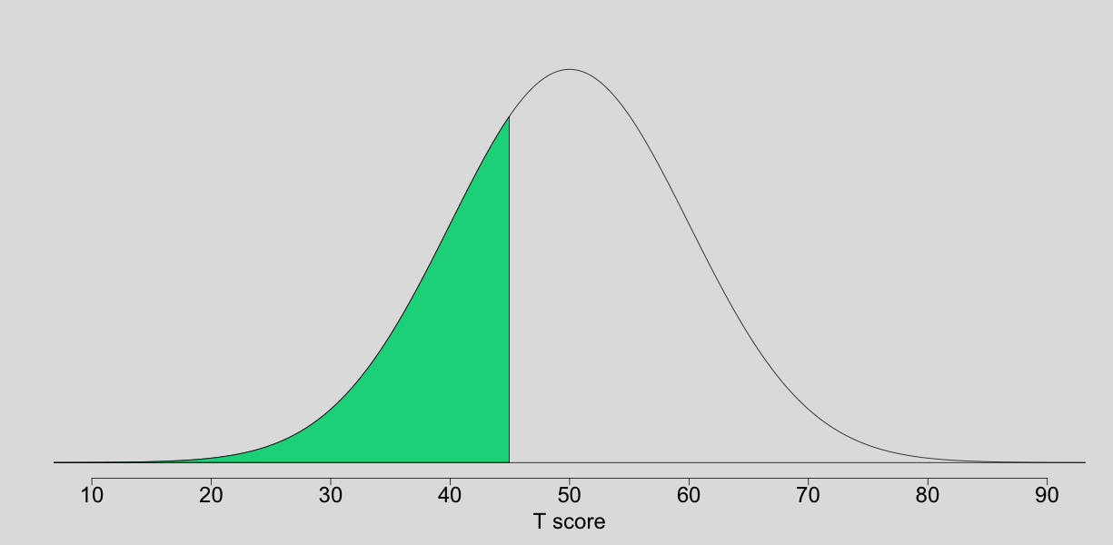

[click for more info about reading this image](https://sapa-project.org/survey/report.php)

Your score on the Neuroticism scale indicates that you are more even tempered than most people. This suggests that you generally experience fewer emotional swings throughout the day and that you react less strongly to stressful events. While you regularly feel negative emotions (fear/worry, sadness, irritability, anger), you likely experience them less often and less intensely than most people. You may still get very upset on rare occasions, but others probably appreciate your relatively calm demeanor.

### ****Openness****

Openness is probably the most broadly encompassing factor of personality. In fact, many people are surprised to learn that the two most widely studied aspects (Intellect and Openness to New Experiences) are highly positively correlated. This positive association can be explained by the fact that both aspects share the common trait of being willing to engage with new ideas. Openness is also associated with traits such as Creativity, Art Appreciation, Introspection, (low) Conformity, and Adaptability. Openness is often presented as healthier or more mature by psychologists, who are often themselves very open. However, open and conventional styles of thinking are useful in different environments. For example, the intellectual style of an open person may be useful for endeavors that reward novelty, but the more conventional approach of an individual who is low on openness often leads to superior job performance in occupations that emphasize procedure and compliance.

**Your score of 50 on Openness places you higher than 50% of previous participants in this survey.**

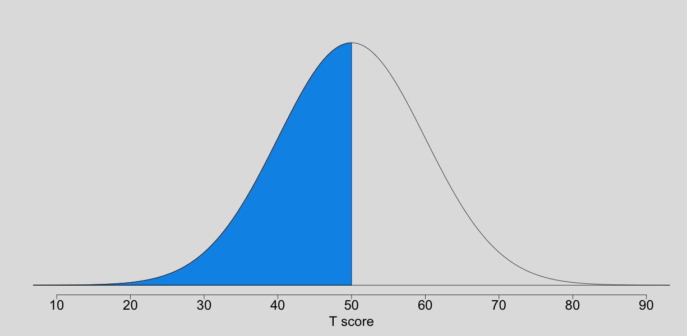

[click for more info about reading this image](https://sapa-project.org/survey/report.php)

Your score on the Openness scale indicates that you are somewhat open to new experiences and intellectual pursuits. You may be comfortable handling quite a bit of information and you also may enjoy thinking about complicated problems or issues. You likely have some appreciation for the arts. You may also be more interested by unconventional ideas than most other people. It is also possible that others consider you to be, at times, both creative and perhaps a little unusual. Generally speaking, open people are intellectually curious, appreciative of art, and sensitive to beauty. Compared to more conventional people, they tend to think and act in individualistic and non-conforming ways. Another characteristic of the open cognitive style is a tendency to think in symbols and abstractions far removed from concrete experience, such as mathematical, logical, or geometric thinking; artistic and metaphorical use of language; music composition or performance; or one of the many visual or performing arts.

**Three: Cognition**

While there are several competing theories in cognitive ability research, there is also growing consensus that abilities are best organized hierarchically. In other words, each of the many different components of cognitive ability involve different sets of skills and these components are typically organized according to similarities among the tasks/skills involved. On the most narrow level, it is often difficult to distinguish between the skills used to accomplish a given task, but on the broadest level (at the top of the hierarchy), general skill sets are more plainly evident. For example, the skills required for different types of verbal tasks are more similar than those required for verbal and spatial tasks.

The items given here include several different types and we are actively working to develop more. In order to keep the test short, each participant is only administered a subset of the question types. Current question types include

* Letter and Number Series,
* Matrix Reasoning,
* Three-Dimensional Rotations,
* Verbal Reasoning (which includes general knowledge, logic and arithmetic questions),
* Figural Analogies,
* Two-Dimensional Rotations,
* Compound Remote Associates,
* Additions and Subtractions,
* Propositional Reasoning, and
* Emotion Recognition.

At this time, we are only giving feedback based on your responses to

* the Letter and Number Series items,
* the Three-Dimensional Rotation items,
* the Matrix Reasoning items, and
* the Verbal Reasoning items.

This is because we don't yet have a big enough sample to generate representative norms for the other item types. Your responses have contributed to the development of these norms for future test-takers.

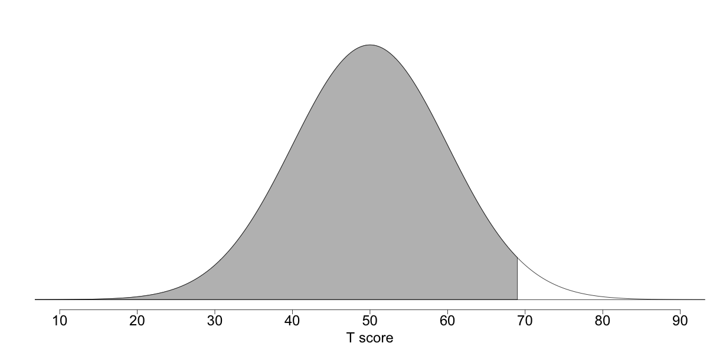

[click for more info about reading this image](https://sapa-project.org/survey/report.php)

**Based on the 5 responses you gave for the item types with norms (see above), your Cognition score was 69. This means that your score was higher than 97% of previous participants in this survey.** The average score for Cognition is 50. While scores on these items are positively correlated with commercial IQ measures, we discourage participants from considering their score to be a proxy for such measures. This "test" differs from most commercial tests in terms of brevity and the fact that it is administered online without a time limit in an un-proctored setting. It is important to take these factors into account when comparing your performance against the average. We recognize that many participants would like to know the correct responses for these cognitive ability items, but we do not currently make this information available in order to maintain the validity of the questions.

[[](http://www.facebook.com/sharer.php?u=https://sapa-project.org/)](http://www.facebook.com/sharer.php?u=https://sapa-project.org/)[[](https://twitter.com/share?url=https://sapa-project.org/&text=Check%20out%20my%20personality%20signature&hashtags=mySPIscores)](https://twitter.com/share?url=https://sapa-project.org/&text=Check%20out%20my%20personality%20signature&hashtags=mySPIscores)[[](http://www.linkedin.com/shareArticle?mini=true&url=https://sapa-project.org/)](http://www.linkedin.com/shareArticle?mini=true&url=https://sapa-project.org/)[[](http://reddit.com/submit?url=https://sapa-project.org/&title=Reddit)](http://reddit.com/submit?url=https://sapa-project.org/&title=Reddit)[[](http://www.tumblr.com/share/link?url=https://sapa-project.org/&title=Tumblr)](http://www.tumblr.com/share/link?url=https://sapa-project.org/&title=Tumblr)[[](https://plus.google.com/share?url=https://sapa-project.org/)](https://plus.google.com/share?url=https://sapa-project.org/)[](mailto:?Subject=mySPIscores&Body=Check%20out%20my%20personality%20signature!%20%20https://sapa-project.org/)